Bansilal Ramnath Agarwal Charitable Trust’s

Vishwakarma Institute of Technology, Pune-37

Department Of Artificial Intelligence and Data Science

# **COMPUTER NETWORK**

**Activity 3**

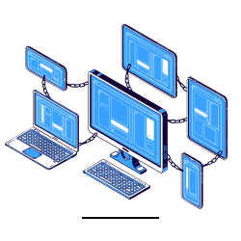

## Class: - SY BTECH Branch: - AIDS

Batch 1- Group 4

23. Avishkar Ghodke

26. Jineshwari Bagul

40. Devang Deshpande

55. Anuj Gosavi

57.Hardik Rokde

**COMPUTER NETWORK & ITS TYPES**

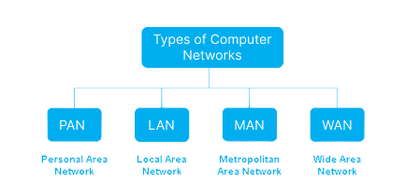

**PAN : Personal Area Network**

A Personal Area Network (PAN) is a small network designed for individual use, connecting personal devices over a short range, typically using Bluetooth, Wi-Fi, or USB.

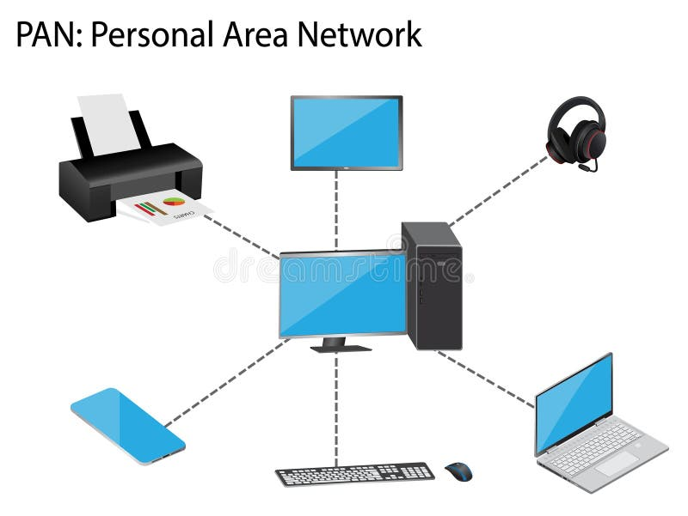

Example: A Smart Home Setup

A person uses a PAN to connect their smartphone, smartwatch, wireless earbuds, and laptop via Bluetooth and Wi-Fi.

This allows:

•Wireless file transfer between devices.

•Syncing notifications from the phone to the smartwatch.

•Streaming music from the phone to wireless earbuds.

A PAN enables seamless communication between personal gadgets, enhancing convenience and productivity.

Figure 1: Personal Area Network

**LAN : Local Area Network**

A **Local Area Network (LAN)** is a network that connects computers and devices within a limited geographical area, such as a home, office, or school. It allows devices to share resources like files, printers, and internet connections.

In an office, multiple employees work on desktop computers and laptops. They need to access shared resources like files, printers, and the internet. Here's how a LAN functions in this scenario:

•Computers & Laptops: Employees use computers and laptops, all connected via LAN cables to a central switch.

•Switch: The switch acts as a hub, connecting all devices in the network.

•Router: The router connects the LAN to the internet, allowing all devices to access online services.

• Printer: A shared printer is connected to the LAN, so employees can print documents from any computer without direct connections.

• File Sharing: Employees can easily share files and collaborate within the network

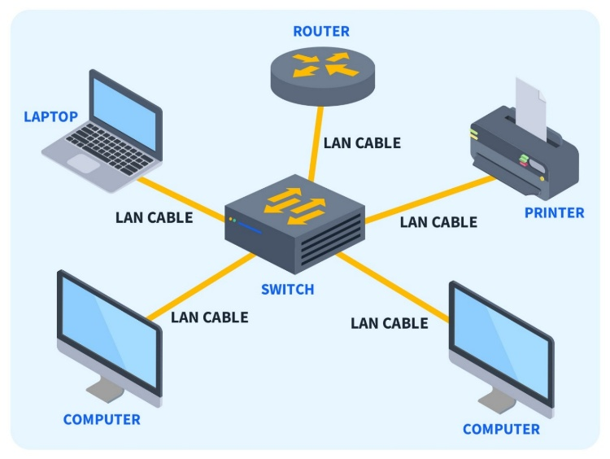

Figure 2 Local Area Network

* **Printer**: A shared printer is connected to the LAN, so employees can print documents from any computer without direct connections.
* **File Sharing**: Employees can easily share files and collaborate within the network

**MAN : Metropolitan Area Network**

A Metropolitan Area Network (MAN) is network that spans city or large campus, connecting multiple LANs over a wider area. It is larger than a LAN but smaller than WAN, often using high-speed fiber optics for communication.

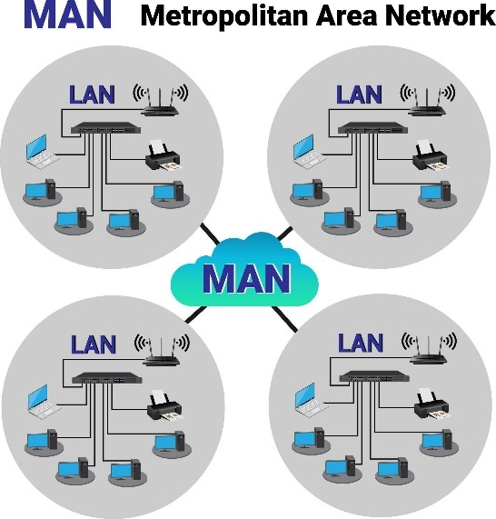

A real-life example of a Metropolitan Area Network (MAN) is a citywide university network similar to our Vishwakarma Group network.

In a large university with multiple campuses spread across a city, each campus has its own Local Area Network (LAN) connecting computers, printers, and servers. However, to enable seamless communication, resource sharing, and centralized management, all these campus LANs are interconnected through a MAN using high-speed fiber-optic connections.

Figure 3 : Metropolitan Area Network

**WAN : Wide Area Network**

A Wide Area Network..(WAN)aais a network that connects multiple LANs and MANs across large geographical areas, such as different cities or countries. It typically uses telecommunication networks, satellites, or the internet for connectivity.

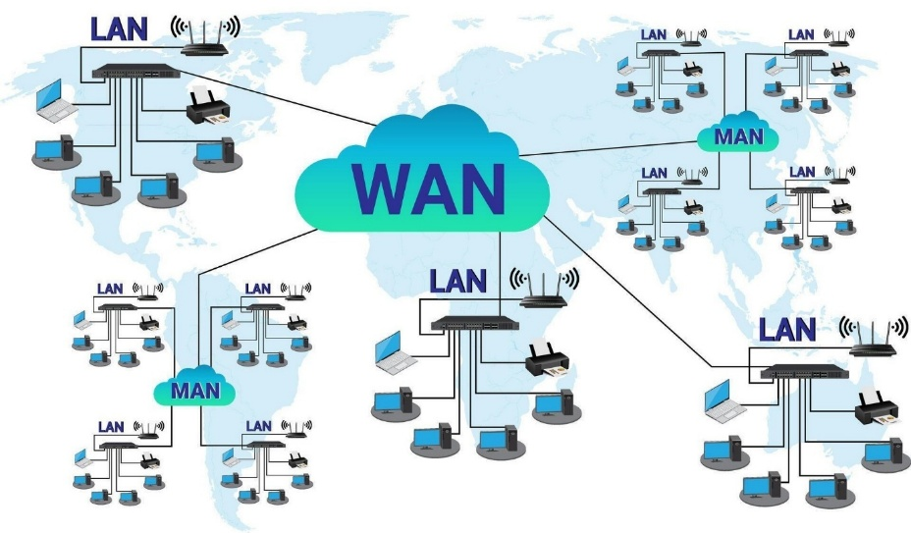

Example : Global Corporate Network

A multinational company with offices in different countries uses a WAN to connect all its branches. Each office has its own LAN, but they communicate through a WAN using leased lines, VPNs, or cloud-based services.

Figure 4: Wide Area Network

**Network Devices**

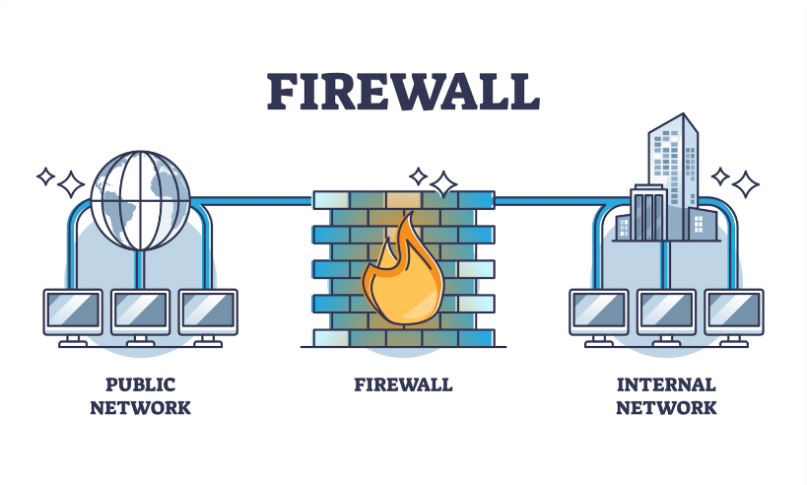

**Firewall-** A firewall is a network security weapon that regulates traffic between trusted internal network and an untrusted external network. Firewalls protect networks against unauthorized access, misuse, and potential attack.

Figure 5: (Firewall)

**Switch-**The Switch is a network device that segments a network into multiple subnets or LANs in order to manage filtering and forwarding packet between those LAN segments based on the MAC address.

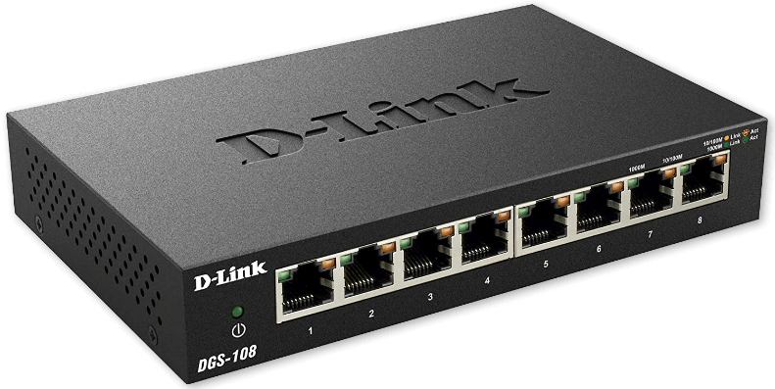

Figure 6: Swtich

**Gateway-** A gateway connects two dissimilar networks, usually with respect to the protocols or data formats used for information transmission. Gateways provide interconnection between networks and the internet.

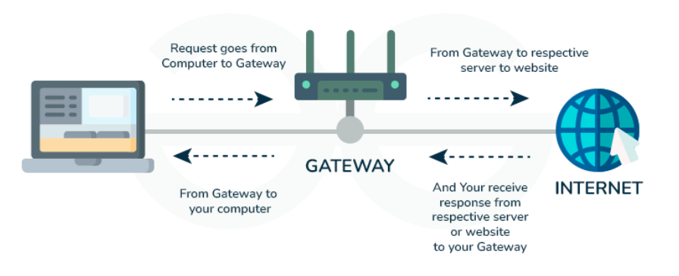

Figure 7: Gateway working

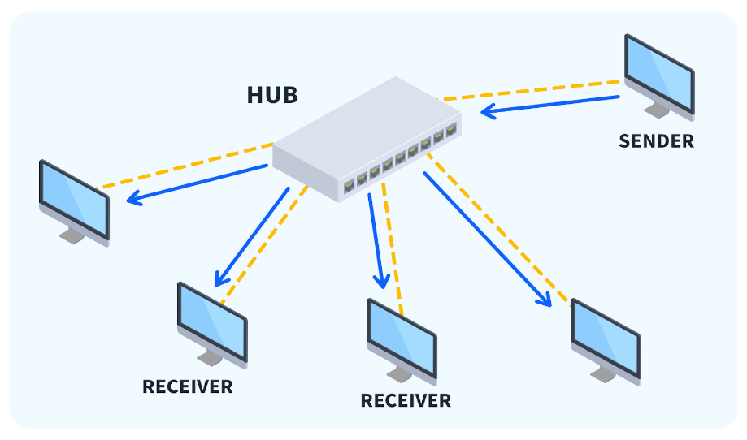

**Hub-** A hub is device that serves as a central point of connection in local area network (LAN). The hub receives transmission signals from a device on the LAN and broadcasts that signal to all systems connected to the LAN, regardless of the ultimate destination of that transmission.

Figure 8 : Hub Connecting multiple devices

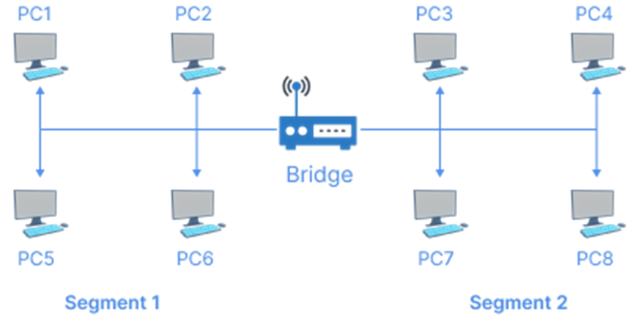

**Bridge-** Connects two or more LANs and filters traffic to reduce collisions and improve efficiency. It provides interconnection with other computer networks that use same protocol. Through bridge, multiple LANs can be connected to form a larger and extended LAN

Figure 9: Bridge